++Software Engineering I

Project Report Part I & II

Group4: Yuwei Jiang, Xinyu Li, Chengyao Wen, Jianing Xu, Chenfan Xiao

**System Statement**

Personal health monitoring can be useful for individuals: providing them with professional and highly-customized food and sports suggestions, motivating them to keep active and have a good habit. Also it gives a lot of potential important information by analyzing the health data collected. It can be used by public health specialists to provide more effective policies in a big way and by manufactures to make products that could really help.

In our project, we will design a system to keep track of users’ health data and provide them with valuable suggestions to achieve their goal. In the background we will design a powerful analyzing system to give feedback about any difference so that several main factors resulting in the difference can be found. Typical suggestions for users including food diet based on their active status. One of the information by analyzing them is whether or what kind of wearable devices can really help. Generally speaking we are going to design a system which will be useful for both users and the ones not using it.

The system will collect the data from wearable health devices - fitbit - using the API provided by the manufacture. Also it will be collecting data from integrated health interface like Apple Health. The data will be uploaded or synced to the server and shared to the client’s friends if permitted. The clients will get visualized graphs of their progress and target daily, weekly and monthly.

We are going to imply APIs from the internet as the specialist to give recommendation to the users. We are still considering using single or multiple API to generate recommendations, because sometimes, there is no definite solution to the healthy diet, not every API would get identical result. So what we are trying to do is to add a function in our system: the system would keep a value to represent the weight of each API we utilized, and the users are presented with different recommendations generated by different API. As a result, certain API would get a increased weight when chosen by the users, and the most weighted API would be labeled as ‘Preferred’ which would make it easier for the user to decide among various options.

The fitbit API will mainly provide the following data: Activity & Exercise, Body & Weight, Friends, Heart Rate and Sleep information. It can be used to track users personal activities and body information. Data will be stored into our databased for further analysis. For recommendation, we will use the API from DailyMile, which will provide us the following functions: Track running route and GPS information and Social functions. With the API from MyFitnessPal, we will be able to access over 20k kind of foods’ information, which can be used for our customized food recommendation system. When the APIs have overlaps, we will use the system above to decide which one is most recommended to clients.

It will be possible for our users to share pictures with others who are not their friends in real life and can share their working out data like steps, running time or active hours with their real friends. Because according to our research, it works better if strangers share pix of themselves while acquaintances share data with each other. This will contribute them to use our system more often and keep track of their health information and be of great help for them to achieve their goal. Also it can provide us more accurate data for foods and sports suggestions as well as background health information search for specialists.

We intend to use PHP and MySQL for our website and we may also develop an Android app to collect users’ health data more efficiently.

**System requirements**

**Functional Requirements**

|  |  |
| --- | --- |
| Identifier | Description |
| Req-1 | The system should attain raw data from the Internet and save it in a  local/online database. |
| Req-2 | The system should process raw data from the local/online database  and obtain the required analysis. |
| Req-3 | The system should allow users to register and provide personalized services. |
| Req-4 | The system should show the recommendation to the user about the healthy diet. |
| Req-5 | The system should obtain information from other social service platform. |
| Req-6 | The system should allow analyst give suggestions about how helpful it is of certain behavior which is commonly believed as helpful. |
| Req-7 | The system should allow analyst provide analysis of health conditions of users from different areas. |
| Req-8 | The system should show the rank of a certain user about his health among his or her friends as well as among the entire users. |
| Req-9 | The system should enable the user to customize his or her diet plan. |
| Req-10 | The system should provide user’s friend health goal with permission. |
| Req-12 | The system shall allow users to invite friends to the system by  sending emails. |
| Req-13 | The system shall allow users to share information of their exercise  activities to social networking websites such as Facebook. |
| Req-14 | The system should show the rank of user in his or her area(can be state,city or even around the house). |
| Req-15 | The system should allow analyst provide analysis about the major contribution to health. |
| Req-16 | The system should provide the graph which satisfy the analyst requirement to the analyst. |
| Req-17 | The system could classify the data by the index(like region, health index) which analyst has input. |
| Req-18 | The system should output the table that contains the data that analyst need. |

**Non-functional Requirement**

|  |  |
| --- | --- |
| Req-1 | The database should keep all the information rather than user’s device. Direct modification from user should be forbidden |
| Req-2 | The system should be simple and easy to use. The webpage should be easy for the user to get the information they want |
| Req-3 | The system should be able to use when related API is updating |
| Req-4 | The response time should be quick |
| Req-5 | The recover time from failure should not be too long |
| Req-6 | The system should enable multiple users to use without overload |
| Req-7 | Minimum maintenance is required, at least once a week |

**User Stories:**

|  |  |
| --- | --- |
| Identifier | User Stories |
| ST_1 | As a User, I can get a look at the average ratings(0-10 pts) and reviews of the software. |
| ST_2 | As a User, I can get a look at the amount of the registered users. |
| ST_3 | As a User, I can read the detail instruction of the software. |
| ST_4 | As a Registered user, I can write reviews and rating. |
| ST_5 | As a Registered user, I can contact with the Software maintainer. |
| ST_6 | As a Registered user, I can get a look at the rank among all the Registered users( among Registered users in my State / among my friends), and get my ranking(%). |
| ST_7 | As a Registered user, I can add friends(or follow other users) and press “like” |
| ST_8 | As a Registered user, I can get a look at friends’ exercise data (daily/weekly) and get comparison data. |
| ST_9 | As a Registered user, I can check my healthy condition (healthy or not). |
| ST_10 | As a Registered user, I can set(change) my health goal. |
| ST_11 | As a Registered user, I can get a recommended exercise plan (based on current health condition and goal). |
| ST_12 | As a Registered user, I can get a recommended wearable equipment. |
| ST_13 | As a Registered user, I can check my daily (weekly average) exercise data. |
| ST_14 | As a Registered user, I can get a costumed meal plan (based on current health condition, daily exercise data and goal). |
| ST_15 | AS a Registered user, I can get a look at my daily health data analysis, (get a score based on the time-distribution and duration of exercise) |
| ST_16 | As a Registered user, I can share information of my exercise activities to social networking websites such as Facebook. |
| ST_17 | As a Software maintainer, I can get feedback from users. |
| ST_19 | As a Software maintainer, I can updates database and modify UI. |
| ST_20 | As a Analysts, I can analyze registered users’ daily data |

**Use Cases**

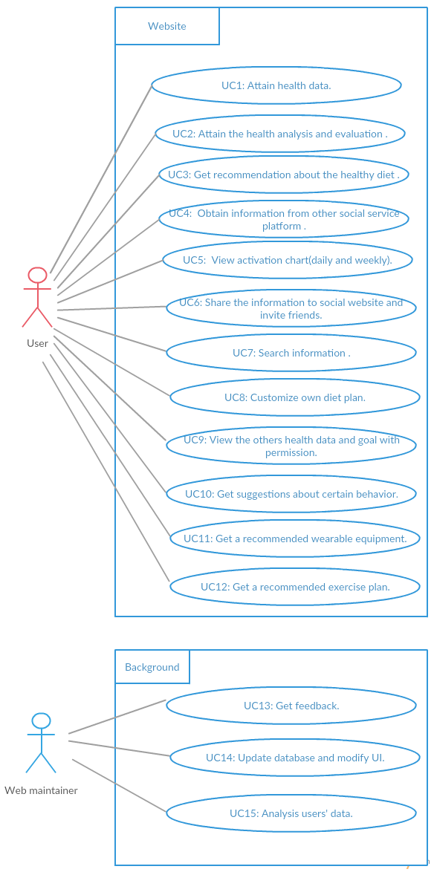

**UI**

**For Users:**

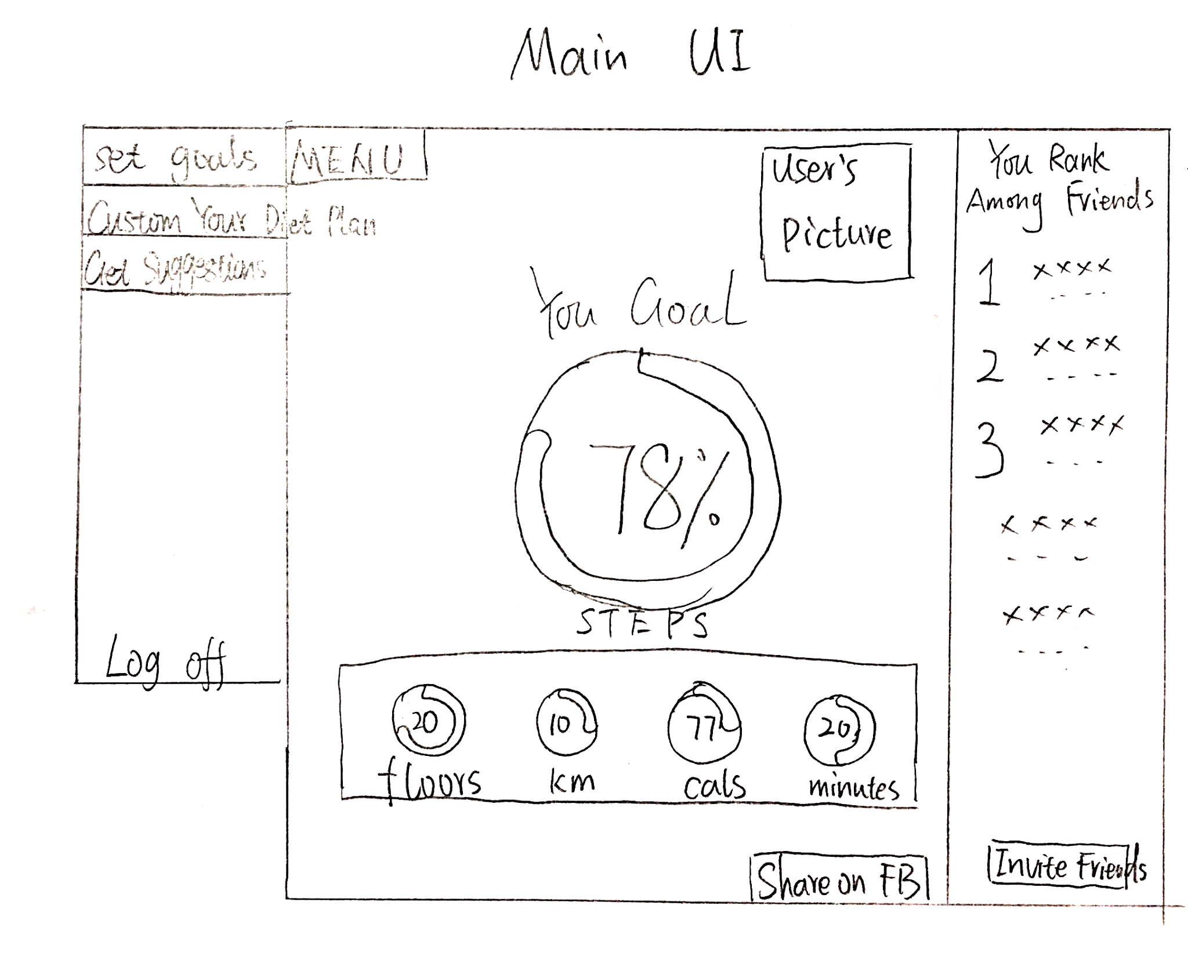

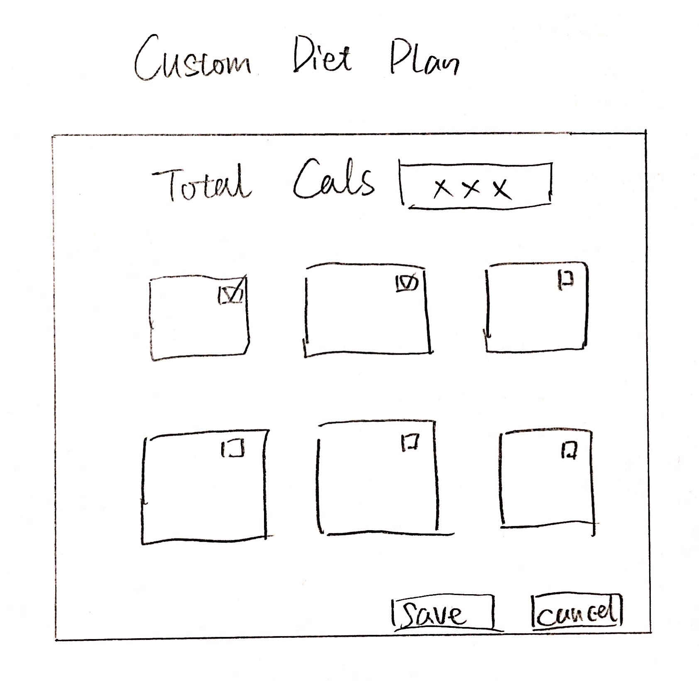

**For Data Analysts:**

